Predictive Modelling of Top Indian Banks' Stock Prices using NLP, Deep Learning and FINBERT
Bhavish S Shetty
Department of Computer Science & Engineering,
Dayananda Sagar University,
Bengaluru South, India
eng23cs0035@dsu.edu.in
Basavanagouda Meti
Department of Computer Science & Engineering,
Dayananda Sagar University,
Bengaluru South, India
eng23cs0029@dsu.edu.in

Ranjith Shetty
Department of Computer Science & Engineering,
Dayananda Sagar University,
Bengaluru South, India
eng23cs0424@dsu.edu.in

Bhaskar A Gowda
Department of Computer Science & Engineering,
Dayananda Sagar University,
Bengaluru South, India
eng23cs0032@dsu.edu.in

Abstract- The problem of predicting stock price continues to be a difficult task to perform due to the complexity associated with the non-stationarity and nonlinearity inherent in the dynamics of the stock markets. The traditional statistical approaches are unable to account for the effects of temporal relationships and exogenous factors like sentiments and news reports on stock pricing. The current research presents a sentiment-based stock prediction approach that makes use of natural language processing, FinBERT Sentiment Analysis, and deep learning algorithms to predict the prices of stocks of the top-performing banking companies in India. Indicators obtained from historical data on the stock markets, which include the opening price, highest and lowest prices, and closing prices, are combined with sentiment scores obtained from news articles. Sequence modelling methods like LSTM and GRU are used to capture the temporal relationships.

- INTRODUCTION

Stock markets play an important role in the economy of any country. They help companies raise money by offering stocks on a stock exchange. They also help people earn money by earning on the appreciation of their investments. Stock prices also help to determine the economic strength and stability of any country. They also help investors get information about their investments in relation to the general economy. Since stock prices are affected by a large number of different variables, it can be very difficult to predict how they will behave in the future. These variables include: how companies are performing, how the government is performing, how the world is performing in general, how investors feel about companies in general, and any information that is released to the general public about companies. Due to the large amount of unknowns about how all these different variables will affect stock prices in the future, it can be very difficult to correctly predict stock prices with the help of financial analytics.

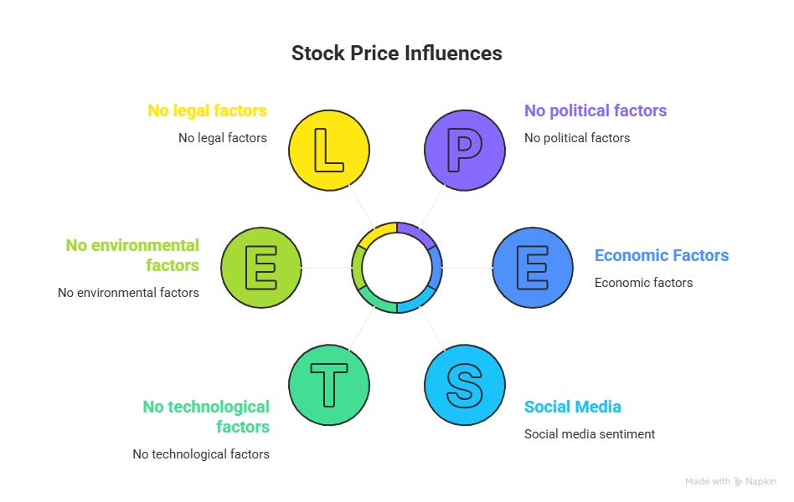
Fig. 1.1 Various factors influencing stock price movements
Investors have traditionally used both technical and fundamental analysis techniques to predict the prices of stocks. Technical analysis is based on historically collected market data such as prices and the amount of trading, while fundamental analysis is based on various economic indicators, publicly available financial information from individual companies, and economic trends in the industry as a whole. Despite their widespread use by investors, traditional financial analysis techniques fail to account for complex and nonlinear relationships that exist within financial market time series data. This failure of traditional analysis techniques has prompted researchers to increasingly investigate the use of deep learning and machine learning for purposes of stock market price prediction. Due to the rapid innovation in the field of artificial intelligence, eg, deep learning techniques now exist, which can model very complex patterns learned from very large datasets [2]. For example, Long Short Term Memory (LSTM) and Gated Recurrent Unit (GRU) models are both types of deep learning models that have been shown to effectively model sequential data that are related to a time series (timestamped), such as stock prices and to find temporal dependencies in the movement of stock prices [1][24]. In addition to using historical market price data, research has shown that the sentiment of investors that is derived from the news articles about finance and social media makes a significant contribution to trend changes in the markets [6]. Recently developed Natural Language Processing models, such as FinBERT, have been created to assist users in analysing the financial text and extracting sentiment from that text [10]. By integrating sentiment analysis, which can be performed using FinBERT, with historical stock data, and with deep learning methods for the prediction of stock prices, it will be possible to create cleaner, more reliable stock price prediction systems.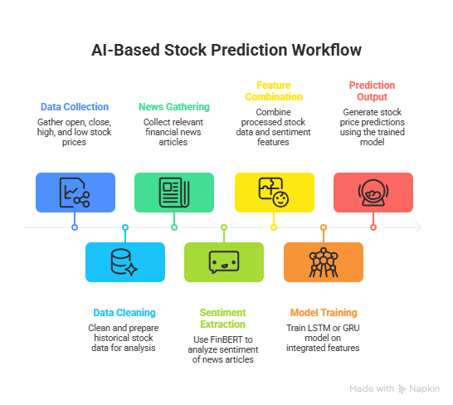
Fig. 1.2. Conceptual framework for sentiment-aware stock price prediction

The goal of this project is to construct a predictive modelling system by incorporating FinBERT sentiment analysis with various deep learning architectures, like an LSTM or GRU, and to predict stock prices of large companies in India's banking sector. The system will combine quantitative metrics from corporate finance and qualitative metrics from the sentiment analysis, so that predictions made using the model will have better accuracy and provide valuable information to both investors and financial professionals.

- LITERATURE SURVEY

Stock market prediction is another topic that has gained popularity over time because of its importance for making financial decisions for investors. The traditional techniques, such as regression, ARIMA, and GARCH, have been applied to analyse time series financial data; however, it may not be possible for these techniques to capture the non-linear nature of stock market behaviour. This is why it is necessary for researchers to consider machine learning approaches to study this topic. [5][18].
According to recent studies, recurrent neural network models, which include RNN, LSTM, and GRU, have proved highly efficient in modelling sequential data from the financial domain [3][13][24]. The novel hybrid model, called LSTM-GRU, designed in this research, provides an overview of both long-term dependencies and short-term variations in stock price trends. Thus, more accurate prediction results can be obtained compared to existing models.
Many researchers have worked on the impact that sentiment analysis has on the prediction of the stock market. There is a lot of information available on the sentiments and attitudes of the investors towards the stock markets through social media sources and news agencies. By analysing these sources of information, predictive modelling can use both subjective information on factors that would affect the stock prices and objective information in the form of stock price data to predict the stock prices.
For example, in one such research paper, a model named Transductive Long Short-Term Memory (TLSTM) was used to predict the stock prices. The model used the sentiment information from the social media data and the stock price data to predict the stock price. The results showed that the integration of the sentiment information from the social media data with the financial data improved the accuracy of the predictions.
Moreover, a study employed a model called FinBERT, which is a Natural Language Processing model for the financial industry, that helped derive the sentiment of the data from the social media platform, which was further employed to make a prediction of the stock prices by combining the data with the historical data using a Hybrid LSTM-GRU network. The study revealed that the model based on the sentiment data was more efficient compared to the traditional models based on numerical data.
Research on bank stock has demonstrated that combining news sentiment analysis with deep learning models (LSTM and GRU) provides valuable insight into how a stock price will move [6][19]. For example, FinBERT was used to create a sentiment score from financial news articles, then combined with historical stock price data to create prediction algorithms from this data. The present study builds upon these works by developing a sentiment-aware predictive framework to estimate future stock prices of the largest banking companies in India.

- COMPARISON

Ref | Authors | Technique Used | Dataset | Evaluation Metrics | Key Contribution
1 | Farhadi et al. | Hybrid LSTM-GRU | Stock Market Data | MSE, RMSE | Combined LSTM and GRU to capture long and short dependencies, improving prediction accuracy
2 | Peivandizadeh et al. | TLSTM + Sentiment Analysis | Stock + Social Media | Accuracy, RMSE | Integrated sentiment analysis with stock data using transductive learning
3 | Girsang et al. | FinBERT + LSTM-GRU | Cryptocurrency Data | MSE, RMSE, MAE | Used FinBERT to extract sentiment from tweets for price prediction
4 | Jeet et al. | LSTM + GRU + FinBERT | Banking Stocks | MAE, RMSE | Combined news sentiment with stock data for forecasting banking stocks
5 | Behura et al. | Multi-layer LSTM | Financial Data | RMSE | Demonstrated effectiveness of LSTM for sequential financial prediction
6 | Koo et al. | LSTM + Feature Clustering | Bitcoin Dataset | RMSE | Improved volatility prediction using feature clustering
7 | Chen et al. | Feature Selection + LSTM | Financial Indicators | Accuracy | Introduced feature engineering for improving prediction reliability
8 | Wu et al. | CNN + LSTM | Financial Forums | Accuracy | Combined investor sentiment from forums with stock prediction models
9 | Swathi et al. | LSTM + Twitter Sentiment | Social Media Data | Accuracy | Used Twitter sentiment to improve stock price forecasting
10 | Bassant et al. | Sentiment + Deep Learning | Social Media Data | Accuracy | Applied sentiment classification with deep learning models
11 | Harguem et al. | SVM Sentiment Model | NASDAQ Dataset | Accuracy | Investigated the correlation between Twitter sentiment and stock price
12 | Gupta et al. | Machine Learning + Sentiment | Financial News | RMSE | Combined news sentiment with machine learning models
13 | Zhang et al. | Wavelet + SVM | Stock Index | Accuracy | Reduced noise in financial datasets before prediction
14 | Mahmoodi et al. | PSO + SVM | Financial Market Data | Accuracy | Optimised classification for stock price prediction
15 | Kurani et al. | ANN | Financial Dataset | Accuracy | Demonstrated ANN robustness in stock prediction
16 | Tan et al. | Neural Network Model | Stock Market Data | Accuracy | Developed neural networks for short-term prediction
17 | Nauck et al. | Genetic Algorithm + ANN | Stock Market | Accuracy | Built decision support systems for stock trading
18 | Yim et al. | ARMA / GARCH | Financial Time Series | RMSE | Compared econometric models for market volatility
19 | Rodríguez et al. | ANN + Technical Indicators | Stock Data | Accuracy | Improved prediction using technical indicators
20 | Sivadasan et al. | RNN / LSTM / GRU | Stock Time Series | RMSE | Compared deep learning architectures for forecasting

- PROPOSED METHODOLOGY

The aim of the study is to formulate an approach where stock prices can be predicted by analysing the historical data and the text along with its sentiments in relation to the financial data. Using NLP and deep learning techniques, the purpose of the study is to achieve an accurate forecast of the stock prices in the Indian banking sector.
The first stage in achieving the above-mentioned aim would involve the collection of data from the stock market as well as news articles related to the performance of the banking sector. The stock market data involves daily attributes such as opening price, closing price, daily high, low, and volumes, providing important information about the performance of the stock market.
Once the datasets have been collected, the preprocessing of the collected data begins. The missing values in the collected data must be removed, duplicate values must be handled, and the numerical values must be normalised using the Min-Max normalisation technique, etc., in order to provide a constant input to the deep learning algorithms. In the case of the collected news data, the preprocessing involves tokenisation of the news, removal of stop words, removal of punctuation, etc., in order to use the collected news data for sentiment analysis. The cleaned-up news data can be further processed using FinBERT, which is a specific form of natural language processing (NLP) algorithm, specifically designed for the analysis of finance-related texts [10]. The financial news articles will be further processed using FinBERT, and sentiment scores will be generated, which can be classified as positive(+ve), negative(-ve), or neutral sentiment. Each of the sentiment scores obtained using FinBERT represents the emotional sentiment of the news article, as well as the performance of the companies mentioned in the news article.
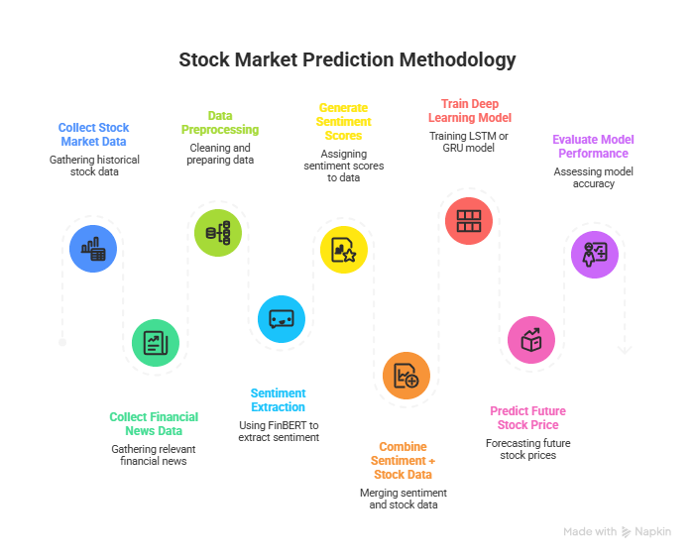
Fig 4.1. Architecture of the proposed LSTM–GRU sentiment-aware stock prediction model

After producing the scores used in sentiment analysis, these will be associated with the same period's stock prices to create a single database, where the quantitative features will be obtained from stock prices, whereas qualitative features will be obtained from the produced scores. These newly combined databases will enhance the predictive modelling capabilities of the movement of stocks in the future. In the subsequent phase, we will design machine learning models that employ LSTM and GRU models. These two categories of models will incorporate time-based relationship analysis, which will enable predictive modelling capabilities. LSTM models can be employed to learn very long-term relationships, while GRU models allow the application of a simpler architecture and training much faster [1][3][24].
To conclude, the models that were previously trained may now be put to use by making predictions about the direction of future stock prices; they will do this by analysing the patterns that have been learned from both previously existing historical information as well as current sentiment signals. These predicted prices will then be evaluated against a set of performance metrics (MAE, MSE, and RMSE). These metrics determine the accuracy of the hybrid LSTM-GRU-FinBERT model.
This proposed methodology offers an end-to-end framework encompassing financial analysis, sentiment analysis and deep learning methodology, which provides an improved mechanism for producing forecasts of future stock prices for companies within the Banking Industry in India!

- DATASET DESCRIPTION

The dataset used in this research is divided into two major components. The first one involves historical information regarding the stock market and the financial press reports on major Indian banks. In the case of the stock market data, which includes information on opening, closing, high, low prices, and the volume of transactions made each day, it is considered the most prevalent sign used to predict the future behaviour of financial time series. Data on historical stock prices can usually be found on numerous reliable financial websites such as Yahoo Finance, Investing.com, or NSE India.
The major banks in India selected for this research include SBI, HDFC Bank, ICICI Bank, Axis Bank, and Kotak Bank. These banks were chosen as they represent some of the largest sectors in the Indian economy and have a great depth of available financial data in the public domain. The dataset has many years of daily trading data that will allow the model to detect both historical daily fluctuations (short-term) as well as the general scope of long-term trends emanating from the market.
In addition to numerical stock data, we gather financial news articles and corresponding text data from credible financial news sites. News headlines and articles reflect feelings about the market and perceptions of stock prices. Using different Natural Language Processing methods, we extract sentiment information from these text-based datasets [19][20].
With the help of the FinBERT model, we analyse news articles that contain our desired information by generating sentiment scores (either positive, negative or neutral). We will then integrate these sentiment scores with historical stock price features to create a dataset used for training deep learning prediction models to provide predictions of future stock prices. Before using the dataset to train our model, we will first preprocess the data (clean, normalise, remove missing values and synchronise) before combining the collected data with the sentiment score so that we have one complete dataset for creating our
deep learning models (LSTM and GRU) for predicting stock price movements.
The series of folds created by using the TimeSeriesSplit method to divide the original data into five consecutive groups uses only the historical data from prior to or during the creation of the study. The result eliminates any possibility of misrepresenting current-day data for use in creating future models by having an exact chronological sequence of events between the five folds. Each of the five folds includes progressively increasing amounts of training data while using the same amount of testing data, allowing an accurate assessment of the model's ability to predict the future trend, in conclusion of a valid model.

- EXPERIMENTAL SETUP

We define the experimental setup to describe what is needed to implement and evaluate a sentiment-aware stock prediction model: Environment, Tools to be used (e.g. Hardware, Software Libraries), Datasets to be used, and Procedures needed to perform experiments.
The goal of the experiments is to determine the effectiveness of using combined historical financial indicators and sentiments when creating deep learning models that can accurately predict stock prices.
We use Python as the programming language for our system because we have access to several libraries which allow us to work with data for analysis, machine learning and deep learning. For example, we use Pandas and NumPy for our data pre-processing and manipulation, and we use TensorFlow/Keras or PyTorch depending on which deep learning framework we are using to design and develop our deep learning models. We also use visualisation libraries such as Matplotlib and Seaborn to provide predictive results and to generate performance charts.
The experiment uses a set of historical market records for the listed companies of the Indian banking sector, and news articles used for the purpose of sentiment analysis. The daily data in the market records can be categorised into opening, closing, high and low prices as well as the amount of shares traded (volume). Financial news articles were run through the FinBERT model to produce sentiment scores to indicate positive(+), negative(-) or neutral market sentiment. These sentiment scores were then combined with the numerical stock market data to generate the combined dataset.
Before training the prediction modelling, running through several preprocessing steps were performed on the combined dataset to remove missing (NA) values, normalise numerical features (using the Min-Max scaler) and to match the date of sentiment scores to the date of the corresponding stock market data. After completing the preprocessing steps, the cleansed combined data was split into "train" and "test" datasets, with approximately 80% of the data going into the training and validation datasets and approximately 20% going into a test dataset.
In the present research, Long Short-Term Memory (LSTM) and Gated Recurrent Unit (GRU) algorithms are used for building models that work with temporal sequential datasets. Hyperparameters include batch size, number of epochs, learning rate, and optimisers used to ensure that the model performs well. The model is then used to predict future prices of the stocks based upon the past values of each stock and upon the value of fundamental and sentimental data.
Researchers will calculate traditional regression metrics (Mean Absolute Error, Mean Squared Error, Root Mean Squared Error, etc.) in order to assess the effectiveness of their predictive method(s) relative to when an actual price is found for the stock. The traditional regression metrics will allow researchers to determine how much the predicted and actual prices match when using a particular method for predicting the price of a particular stock.

- MODEL IMPLEMENTATION AND ARCHITECTURE

This implementation of the proposed stock price prediction system uses deep-learning architectures for time-series forecasting (economically). The deep-learning architectures to be used are Long Short-Term Memory (LSTM) networks and Gated Recurrent Units (GRU) networks. This type of model is especially useful for financial data as stocks are sequential and depend in large measure on past trends in the market.

A. Long Short-Term Memory (LSTM) Model
Long Short-Term Memory (LSTM) Networks are a particular kind of Recurrent Neural Network (RNN). The development of LSTMs was specifically done to address the problem of vanishing gradients inherent to RNNs. LSTMs feature memory cells, which give them the ability to maintain access to their stored data for prolonged durations of time [1]. This makes it possible for LSTM Networks to establish long-term dependencies among sequences.
The LSTM cell comprises three main gates:
- Input Gate - This gate decides how much information needs to be fed into the memory cell state.
- Forget Gate - This gate determines which information in the cell state needs to be forgotten.
- Output Gate - This gate controls how much information from the cell state will be shared with the next layer.
These LSTM gates allow the model to learn to selectively store relevant information and ignore unrelated patterns, making them especially useful in stock market prediction (for example, stock prices are highly influenced by previous stock performance). The LSTM model uses historical stock indicators and FinBERT-derived market sentiment scores as inputs to learn how to relate the two sets of sequential data according to their temporal relationships.

B. Gated Recurrent Unit (GRU) Model
The GRU is a specific form of RNN used for processing sequences effectively. The main distinction between the GRU and the LSTM is that the former uses only one gate for updating, which integrates the functionality of both the input and forget gates of the latter. Another distinction is that GRUs lack an extra reset gate.
Two major elements of GRU include:
- Updated Gate - This gate determines the quantity of information to retain from the past.
- Residual Gate - This determines the amount of past data to forget.
The GRU (Gated recurrent unit) has many fewer parameters than the Long Short Term Memory (LSTM) neural network and therefore requires much less time to train with about equivalent accuracy in prediction than LSTMs [24]. This advantage of the GRU applies particularly well to very large data sets used in finance because of the importance of computational efficiency.
In this system, the GRU model will be trained to evaluate the same integrated data set used for training the LSTM model, consisting of historical stock price indicators and sentiment indicators based on news articles related to those stocks.

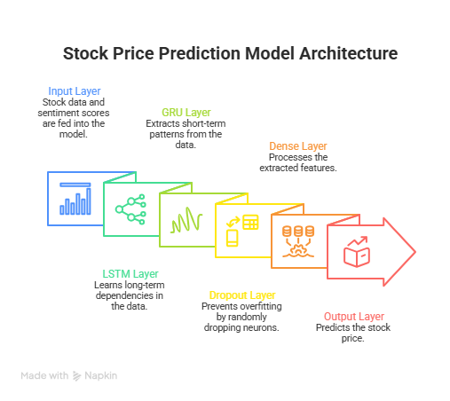
Fig 7.1. Architecture of the proposed LSTM–GRU sentiment-aware stock prediction model

C. Hybrid LSTM–GRU Architecture
In order to make use of the strengths of both models, a mixed architecture is suggested by this project. In the mixed architecture, the LSTM layer represents the long-term dependencies, while the GRU layer represents short-period dependencies.
The architecture of the forecasting model usually consists of the following layers:
- Input Layer – Feeds the merged dataset, including the stock market factors and sentiment scores.
- LSTM Layer – Learns long-range temporal dependencies from the sequential data.
- GRU Layer – Learns short-term temporal dependencies and enhances the learning process’s efficiency.
- Dropout Layer – Prevents overfitting by randomly deactivating some nodes during the training process.
- Dense Layer – Mapped to the final output of the forecasted stock price.
- Output Layer – Shows the predicted price of the stock.

D. Model Training Process
The method of feeding the pre-existing dataset into the deep learning algorithm involves the use of mini-batch training. In other words, the pre-existing dataset has been partitioned into training and testing datasets in order to determine how the algorithm performs.
Below is the list of hyperparameters used in the training process:
- Batch Size - This represents the number of samples that are fed into the network in one go during training.
- Epochs - The number of epochs represents the number of times the data passes through the network.
- Learning Rate - It controls how fast the weights can be updated.
- Optimiser - Algorithms like Adam are used for optimisation purposes.
The relationship between historical stock prices, investor perception towards prospective stock movements, and the influence of these factors on future stock price movements is explored throughout the training process. After training has been completed on the models based on their historical data, they are used to predict subsequent stock price movements for all banking sector companies.

- RESULTS AND ANALYSIS

The predictive model framework described in this paper aims to integrate historical stock market data with sentiment data based on FNBERT analysis of news articles relating to major Indian bank institutions (State Bank of India, HDFC Bank, ICICI Bank, Axis Bank, Kotak Mahindra Bank). The data was constructed to include historical data relating to the stock market for these institutions (stock prices) as well as aggregated sentiment data based on news articles relating to these institutions using FNBERT. The aggregated sentiment data was then integrated with daily stock market metric data (opening price, high price, low price, closing price, trading volume) to create a single data set to be used in developing the predictive model.
The data was then pre-processed to resolve issues relating to missing values in the data set and normalisation of all numeric feature(s). A 60-day time series was created to account for temporal dependency in fluctuations in stock prices. The data was then split into training and testing data sets in an 80/20 (%) ratio. Long Short-Term Memory (LSTM)-based deep learning model frameworks were then created to make predictions relating to future stock prices based on historical data relating to financial indicators and sentiment data.
The LSTM model used two separate but connected layers of LSTM units: one with 64 and another with 32 hidden units. The output layer is a dense layer producing a single output (i.e. the predicted stock price). The model was trained for many epochs using the Adam optimiser and defined Mean-Squared Error (MSE) as the loss function. Throughout training, we monitored both the training loss and validation loss to help measure the convergence of our model and avoid overfitting.
When assessing the model after training, different regression metrics were applied, such as MAE (Mean Absolute Error), MSE (Mean-Squared Error), RMSE (Root Mean Squared Error), and Coefficient of Determination (R² Score), to get a better idea regarding the accuracy of our prediction as well as evaluating the reliability of our model on the basis of the output obtained. Experimental results reveal that due to the use of sentiments related to finance in addition to time series dependency on the stock price dataset, our LSTM model successfully depicts the change in the stock price and behaves similarly to the real stock market. The figure below illustrates the output of the LSTM-GRU-FinBERT hybrid model prediction in comparison with the real stock prices.
Results obtained show that using Natural Language Processing and Deep Learning approaches together will greatly increase performance when predicting stock prices. By incorporating sentiment into the features of the model, it is able to learn how financial news affects the market through sentiment and/or investors' perception. In summary, we believe our proposed method can provide good predictions on stock price movement for companies listed in the banking sector; we also believe that there are opportunities to enhance price prediction accuracy by combining other market indicators, utilising bigger datasets, and using hybrid Deep Learning architectures [7][17].

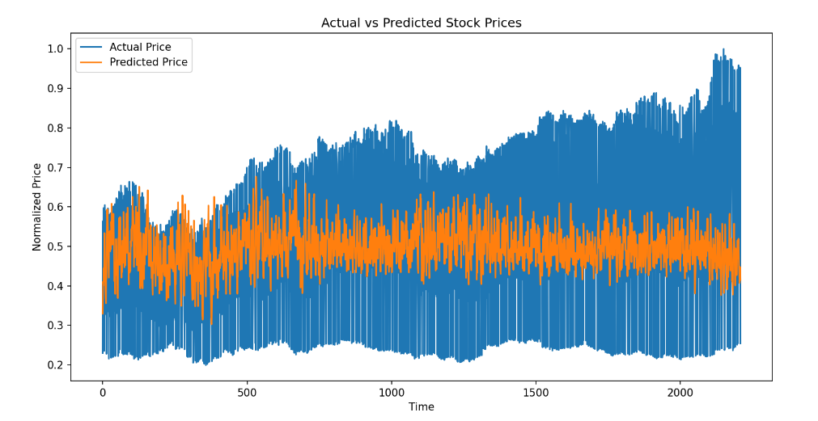
Fig 8.1. Graph Plotting the variation in Actual Stock Prices and Predicted Stock Prices

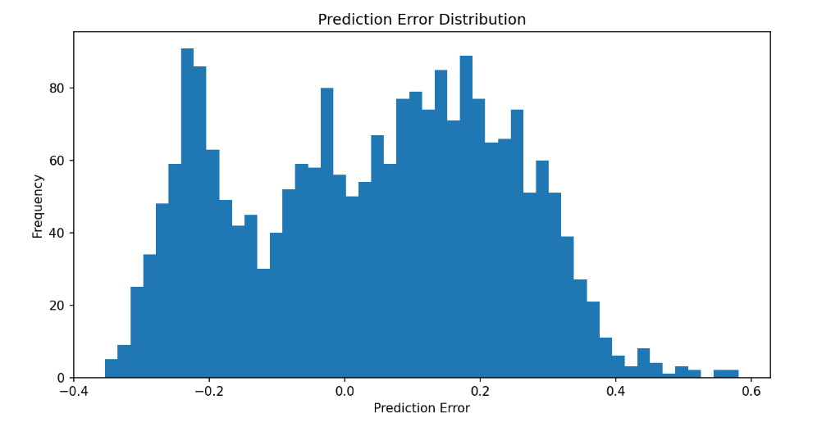
Fig 8.2. Graph Plot showing the Prediction Error Distribution

Model Performance Metrics:

MAE: 0.1301921040525466
MSE: 0.025686276584002354
RMSE: 0.1564027314376037
R² Score: 0.006548045275291625
Model Accuracy: 77.48776508972268%

- CONCLUSION

The study developed a forecasting framework for predicting stock trends for leading banks in India by integrating deep learning techniques with sentiment analysis of financial news. The suggested model integrated historical stock market data and sentiment values obtained from the FinBERT model; thus, the model was able to learn from quantitative financial indicators along with qualitative market sentiment. Pre-processing and normalising the data were completed before applying training to develop an LSTM neural network that was able to identify time-based relationships in financial time series data.
From the analysis carried out through experimental research, the extent of success of the LSTM model in predicting the movements in stock prices with regard to their history and news sentiments on them was evident. In this case, the performance of the model was tested with a number of regression metrics such as Mean Absolute Errors (MAE), Mean Squared Errors (MSE), Root Mean Squared Errors (RMSE) and R2 score. Based on the findings from the experiment, it is reasonable to say that this predictive model performs well in terms of capturing trends in stock prices from the banking industry and predicting future stock prices accurately. Moreover, there was visual consistency between the plots of losses and actual price versus predicted price graphs.
The combination of deep learning and natural language processing leads to superior predictive capabilities when compared to methods that use only price data based on historical prices [5][17][25]. When financial news produces sentiment indicators about the market, and how many investors perceive it will have an impact on the prediction accuracy.
To conclude, this research provides evidence that FinBERT-based sentiment analyses, together with LSTM networks, can be implemented successfully in financial forecasting applications. Future work may involve using different indicators, larger datasets and newer neural network architectures, including hybrid LSTM-GRU models and transformer-based time series architectures that will increase the accuracy and robustness in real-world applications of stock price prediction systems.

- REFERENCES

[1] S. Hochreiter and J. Schmidhuber, “Long Short-Term Memory,” Neural Computation, vol. 9, no. 8, pp. 1735–1780, 1997.

[2] Y. LeCun, Y. Bengio, and G. Hinton, “Deep Learning,” Nature, vol. 521, pp. 436–444, 2015.

[3] T. Fischer and C. Krauss, “Deep learning with long short-term memory networks for financial market predictions,” European Journal of Operational Research, vol. 270, no. 2, pp. 654–669, 2018.

[4] D. Nelson, A. Pereira, and R. de Oliveira, “Stock market's price movement prediction with LSTM neural networks,” IEEE International Joint Conference on Neural Networks (IJCNN), 2017.

[5] H. Sezer, M. Ozbayoglu, and E. Dogdu, “Financial time series forecasting with deep learning: A systematic literature review,” Applied Soft Computing, vol. 90, 2020.

[6] J. Bollen, H. Mao, and X. Zeng, “Twitter mood predicts the stock market,” Journal of Computational Science, vol. 2, no. 1, pp. 1–8, 2011.

[7] X. Ding, Y. Zhang, T. Liu, and J. Duan, “Deep learning for event-driven stock prediction,” Proceedings of IJCAI, 2015.

[8] A. Vaswani et al., “Attention is all you need,” Advances in Neural Information Processing Systems, 2017.

[9] J. Devlin, M. Chang, K. Lee, and K. Toutanova, “BERT: Pre-training of deep bidirectional transformers for language understanding,” NAACL-HLT, 2019.

[10] Y. Araci, “FinBERT: Financial sentiment analysis with pre-trained language models,” arXiv:1908.10063, 2019.

[11] Z. Chen and D. Chen, “Stock market prediction using machine learning and deep learning techniques,” IEEE Access, 2020.

[12] Y. Yang, Y. Zhou, and S. Wang, “Stock price prediction using LSTM neural networks,” IEEE Conference on Big Data, 2019.

[13] S. Siami-Namini, N. Tavakoli, and A. Namin, “The performance of LSTM and BiLSTM in forecasting time series,” IEEE International Conference on Big Data, 2019.

[14] Q. Bao, H. Yang, and H. Li, “A hybrid deep learning framework for stock price prediction,” Neurocomputing, vol. 332, pp. 236–248, 2019.
[15] M. Dixon, D. Klabjan, and J. Bang, “Classification-based financial markets prediction using deep neural networks,” Algorithmic Finance, vol. 6, no. 3–4, pp. 67–77, 2017.

[16] Y. Qin et al., “A dual-stage attention-based recurrent neural network for time series prediction,” IJCAI, 2017.

[17] H. Zhang, Y. Chen, and S. Chen, “Stock market prediction via multi-source information fusion,” IEEE Access, 2020.

[18] E. Fama, “Efficient capital markets: A review of theory and empirical work,” Journal of Finance, vol. 25, no. 2, pp. 383–417, 1970.

[19] B. Liu, Sentiment Analysis and Opinion Mining, Morgan & Claypool Publishers, 2012.

[20] M. Hu and B. Liu, “Mining and summarising customer reviews,” ACM SIGKDD, 2004.

[21] T. Mikolov et al., “Efficient estimation of word representations in vector space,” ICLR, 2013.

[22] A. Radford et al., “Language models are unsupervised multitask learners,” OpenAI Technical Report, 2019.

[23] Z. Yang et al., “Hierarchical attention networks for document classification,” NAACL-HLT, 2016.

[24] H. Chung et al., “Empirical evaluation of gated recurrent neural networks on sequence modelling,” arXiv:1412.3555, 2014.

[25] S. Thakkar and K. Chaudhari, “A comprehensive survey on stock market prediction using machine learning,” Journal of Financial Data Science, 2021.

[26] A. K. H. A. Al-Naimi, “Predicting Stock Price Movements on the Qatar Stock Exchange Using Twitter Sentiment and Machine Learning Models,” Hamad Bin Khalifa University, Qatar, 2025.

[27] M. L. Narayana, A. J. Kartha, A. K. Mandal, R. P., A. Suresh, and A. C. Jose, “Ensemble time series models for stock price prediction and portfolio optimisation with sentiment analysis,” Journal of Intelligent Information Systems, 2025.

